‘More than just Jutland’: the Royal Navy at war. 1914-1918
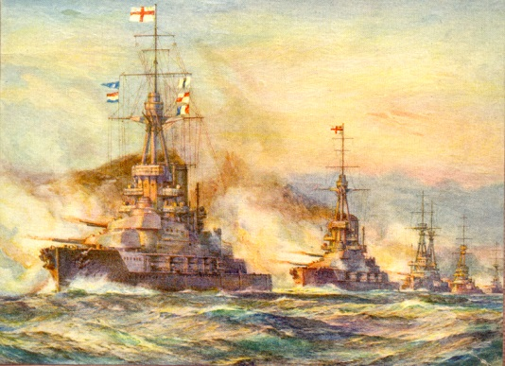
Saturday 21 May 2016
09.30-17:30
Lecture Theatre B, Building 65
Avenue Campus

09:30 | Arrival and refreshments
10:00 | Welcome and introduction: Southampton, birthplace of Admiral Lord Jellicoe  Professor Adrian Smith, Emeritus Professor of Modern History, University of Southampton
10:15 | The Royal Navy, 1914-1918  Dr Duncan Redford, Author, defence analyst, and Honorary Senior Research Fellow in Modern Naval History, University of Portsmouth
11:15 | Coffee Break
11:30 | Jutland in Context  Dr M. A. Farquharson-Roberts, National Museum of the Royal Navy, Surgeon Rear Admiral (Rtd.)
12:30 | Lunch
13:30 | The Material culture of the Royal Navy during the First World War  Dr Quentin Colville, Curator of Naval History, National Maritime Museum
14:30 | ‘Mapping the national impact of the Jutland Battle: civic and community responses during the First World War’  Dr Brad Beaven, Reader in Social and Cultural History, University of Portsmouth and Dr Mel Bassett, University of Portsmouth.
15:10 | Commemorating the war at sea  Dr Glyn Prysor, Chief Historian, Commonwealth War Graves Commission
16:00  16:15  16:45 -17:30 | Tea and screening of four short propaganda films on the Royal Navy at the onset of war  Conclusion and overview of the day  Professor Adrian Smith, Emeritus Professor of Modern History, University of Southampton  Post conference screening of the BFI’s 2014 restoration of The Battles of Coronel and Falkland Islands (Walter Summers/British Instructional Films/ 1927)

